THE ORIGIN OF WOLVERINE

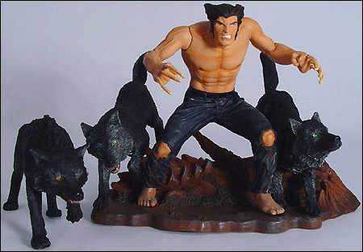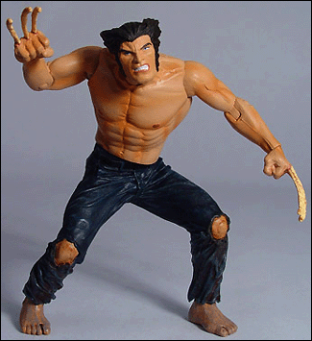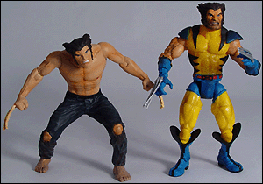

Super Hero Stuff.Com
Origin Wolverine Action Figure
$18.99 - Comes with Wolf Pack and stand. Read below for specifics.
"The story begins a long time ago, at the end of the 19th century with a young boy named James Howlett. The child is weak and sickly, and generally unremarkable beyond that. Until... things get a bit messy back at the ranch when the groundskeeper gets a little postal after being fired. Logan (the man's name, and future alias for Wolverine) decides to get some revenge and what should stop him, but young James's newly revealed bone claws. At the time they are just nubs, but they grow to full size as he reaches adulthood.
The claws are quite a shock to James, and his friends and family, and he has to head out on his own to settle things. He eventually ends up living in the woods with wolves as a wild man for a time, and it is much later in his life (which seems endless since his healing factor keeps his aging at a very slow rate) that he gets his skeleton laced with adamantium. He eventually works for the Canadian government, quits with them and finds his place in the X-Men, a role he still fills.
The figures are all packaged in large blister cards and they are designed to have a flat spine with imagery of the character, so they can be placed on a shelf like books if you're inclined to keep your figures unopened. All the figures are built around a seven-inch scale, meaning a six foot tall character would be seven inches as a figure. This scale is consistent with the other figures in the line.
Origin Wolverine follows the same model that has defined Marvel Select - good sculpting, a detailed display base and limited articulation. The articulation is mostly in the upper body, with ball-jointed shoulders, bending elbows, twisting wrists, neck and waist. Below the belt there are only twisting ankles, and since the figure is also sculpted in a hunched position (as if he were out hunting) knee joints might not be that much help. He's 5.25 inches tall hunched over, and this is about right for the scale of the line. This also makes him a little shorter than the Marvel Legends Wolverine, who was actually scaled a bit too tall for Legends. The display base is a log in the woods, and there are three companions with Logan to make sure you can get in some four play. He has three unarticulated wolves with him, all of which can stand on their own. The display base is pegged to hold Wolverine and two of the wolves, with the wolves posed as if they are jumping over the log. This figure was sculpted by Shawn Nagle." - from Toy Mania.Com

